Window Shopper –Non Catalog Supplier

A Non-Catalog supplier is one who has favorably negotiated a Statewide Contract (SWC), but who does not have a catalog in Team Georgia Marketplace Virtual Catalogs. To make this purchase, you will either fill in a form, or will be provided additional instructions on how to complete the purchase.

Step | Do This:
1 | Begin with a keyword search. This example uses mail equipment.  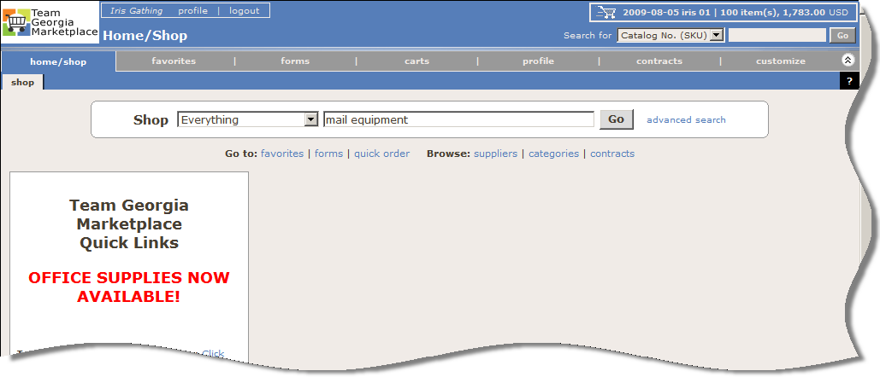  Note: You do not have to determine if the supplier requires a form.
2 | When the search results display, you will see "Mail Equipment Form", and also at the end of the line, a View Form button.  This example will use Hasler as the supplier.  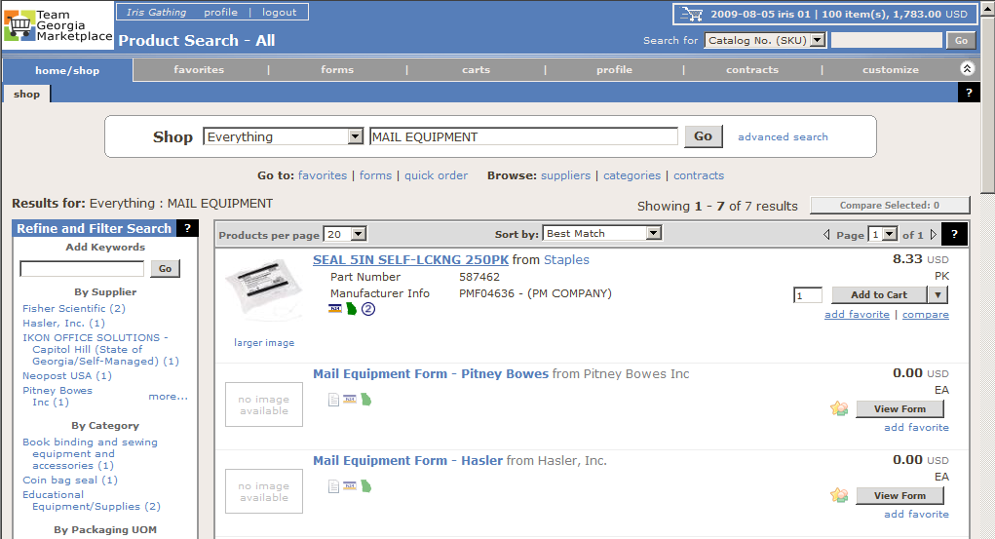

3 | Fill in or select the necessary information to complete the form.  To submit the form, select the Add and go to cart option at the top of the screen, and click the Go button  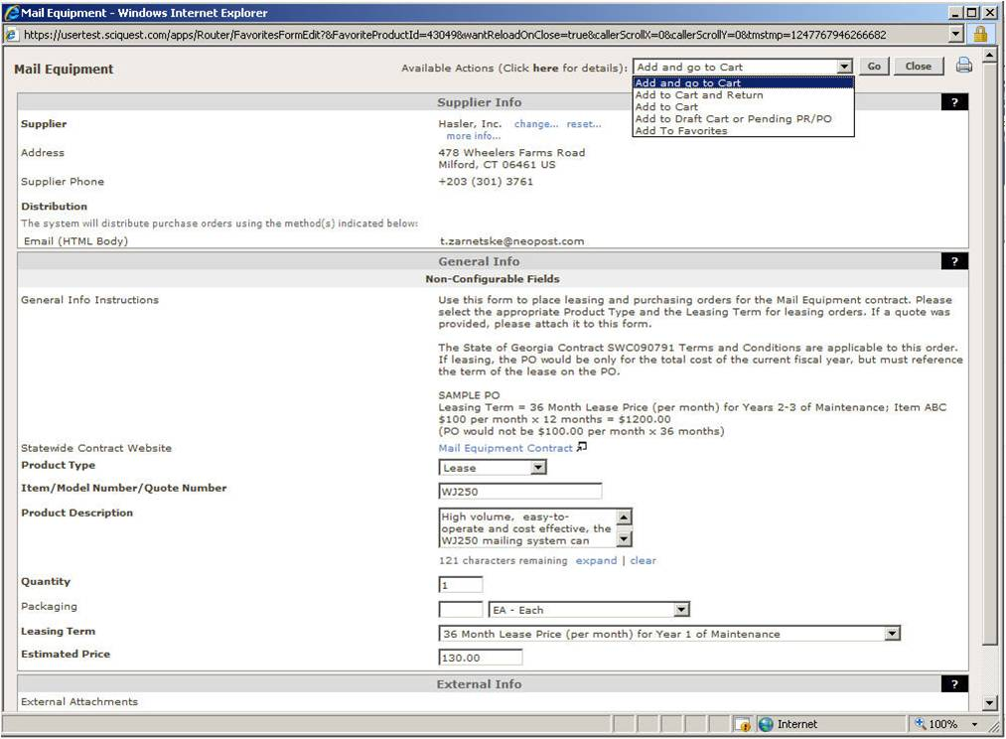
4 | This will add the item to your shopping cart with the completed form attached. At this point, you can click the form icon or the more info...link.  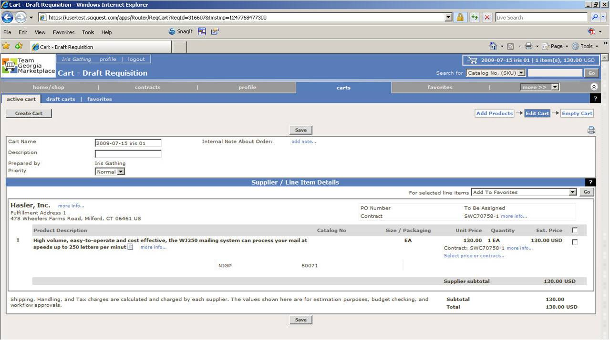

5 | You will have option to print the form so you can fax it, or scan and email it as needed.  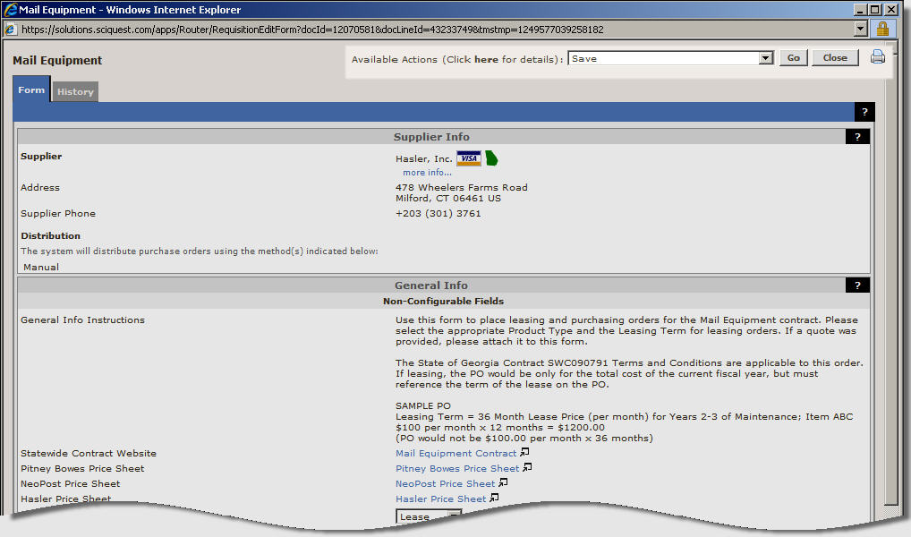
7 | End of Procedure

